





**Paint Booth Permit-by-Rule**

**Quick Guide Instructions for**

**Iowa EASY Air**

Iowa Department of Natural Resources

Wallace State Office Building

Air Quality Bureau

502 E 9th St

Des Moines, IA 50319

Phone: (515) 725-8200

**Contact the Iowa EASY Air Helpdesk**

**Email:** [**easyair@dnr.iowa.gov**](mailto:easyair@dnr.iowa.gov)

**Or call (515) 725-9569 or (515) 204-3749**

# Table of Contents

Table of Contents 2

List of Figures 2

1. Adding the Paint Booth Permit-by-Rule Application to Your Account 3

2. Finding the Paint Booth Permit-by-Rule Application 6

3. Filling Out and Submitting a Paint Booth Permit-by-Rule Application 7

3.1 Facilities Eligible for Permit by Rule 8

3.2 Contact Information 8

3.2.1 Facility Contact Information 8

3.2.2 Facility Information 9

3.3 Applicability Question 9

3.4 Lead Applicability 12

3.5 Spray Booth Description 12

3.6 Spray Booth Certification 14

3.7 Attachments 15

3.8 Validation 17

3.9 Payment 17

3.10 Submission 18

# List of Figures

Figure 1 Dashboard Buttons to Create a New Submittal 3

Figure 2 Submittal Menu 3

Figure 3 Link to Submittal Types Associated with my Account 4

Figure 4 Available Submittal Types 4

Figure 5 My Account Menu 5

Figure 6 Basic Information Tabs 5

Figure 7 Associate Facility Button 5

Figure 8 Associate Facility Search 6

Figure 9 Facility Search Results and Adding Submission Type 6

Figure 10 Dashboard Buttons to Create a New Submittal 7

Figure 11 Submittal Menu 7

Figure 12 Construction – Paint Booth Permit-by-Rule Icon 7

Figure 13 Facilities Eligible for Permit by Rule Statement 8

Figure 14 Facility Contact Information 8

Figure 15 Facility Information 9

Figure 16 Applicability Question Summary 9

Figure 17 Spray Booth Description Screen 12

Figure 18 Spray Booth Description Detail Screen 12

Figure 19 Spray Booth Description Example 14

Figure 20 Attachment Screen 15

Figure 21 Attachment Screen 16

Figure 22 Example Attachment Screen 16

Figure 23 Example Validation Screen 17

Figure 24 Example Payment Screen 18

Figure 25 Example Certificate of Submission Screen 18

Figure 26 Confirmation of Submittal 19

This document provides directions on how to apply for a Paint Booth Permit-by-Rule in the Iowa EASY Air System.

(Note: This document is written to explain how a Responsible Official can submit a Paint Booth Permit-by-Rule. As with other submittal types within the Iowa EASY Air system, the Responsible Official may delegate the completion of these forms to a Preparer. The Preparer can complete the forms and have the Responsible Official complete the certification and submit the Permit-by-Rule application. The instructions for assigning a Preparer for a facility and submittal type are covered in other parts of the Iowa EASY Air documentation.)

# Adding the Paint Booth Permit-by-Rule Application to Your Account

Before you are able to apply for a Paint Booth Permit-by-Rule in the Iowa EASY Air system, you will need to add the Paint Booth Permit-by-Rule application to your account.

**Viewing Associated Application Types**

If you do not know what application types are associated to your account, you may navigate to the Air Department Submittal Type List page and view the submittal types associated with your account. There are two ways to the Air Department Submittal Type List page within the Iowa EASY Air system.

For one method, on your dashboard click on the “Apply for a New Submittal” button in the upper left-hand corner of the dashboard as shown in Figure 1.

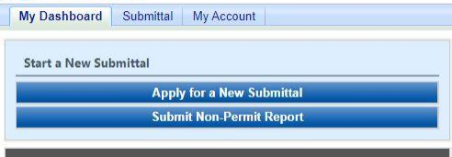

Figure 1 Dashboard Buttons to Create a New Submittal

Alternatively, hover over the Submittal dropdown menu and select “Start a New Submittal” as shown in Figure 2.

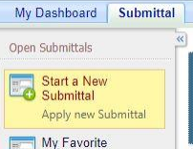

Figure 2 Submittal Menu

Next, you will see the application icons for the different types of submittals available to you in the system as shown in Figure 3.

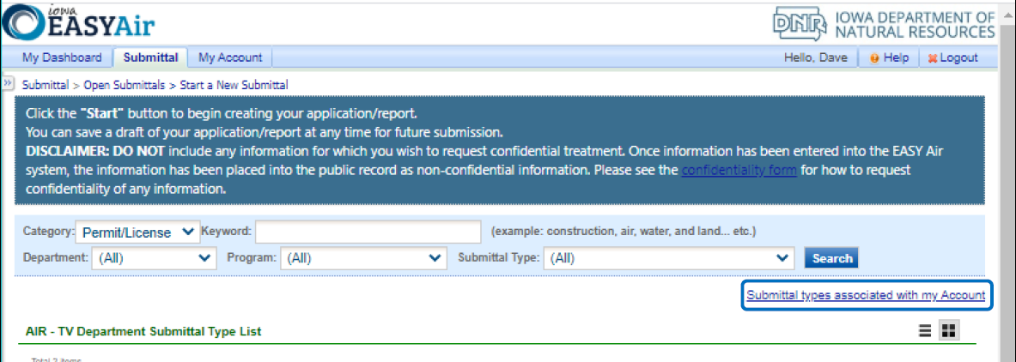

Figure 3 Link to Submittal Types Associated with my Account

Next, click on the link labeled “Submittal types associated with my Account” on the right side of the screen and the “Available Submittal Types” screen will appear as shown in Figure 4. On this screen, you are able to view the available submittal types and the submittal types already associated with your account.

A screenshot of the "Available Submittal Types". Two sections are shown, the "Available Submittal Types" and "Submittal Type Association Instruction".

Figure 4 Available Submittal Types

If you don’t see the Paint Booth Permit-by-Rule application associated with your account, click on “Add More”. This will take you to the “Basic Information” page. Follow the instructions below to associate the application type.

**Associate an Application Type**

To associate an application type to your account, you will need to navigate to the “Associate Facilities” tab. To navigate to the “Associate Facilities” tab, on your dashboard hover on “My Account” and click on “Basic Information” as shown in Figure 5.

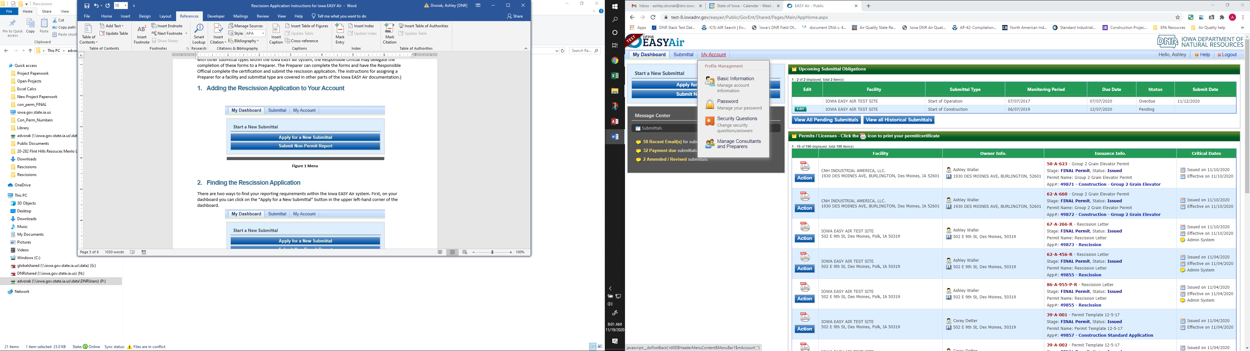

Figure 5 My Account Menu

The Basic Information page will appear. As shown in Figure 6, this page will have four tabs on top. Click on the “Associate Facilities” tab. This tab will show all your associated facilities and application types you currently have on your account.

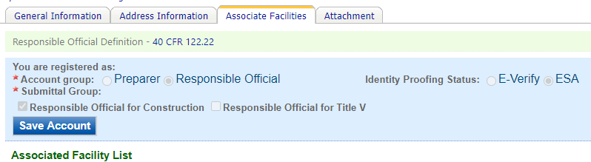

Figure 6 Basic Information Tabs

Next, scroll to the bottom of the page and you should see three buttons, as shown in Figure 7 below. Please click on “Associate Facility”.

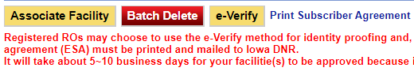

Figure 7 Associate Facility Button

The facility search will appear as shown in Figure 8 below. Enter in your facility information and click, “Search”. You may search by Facility Name, Address, or Facility Number.

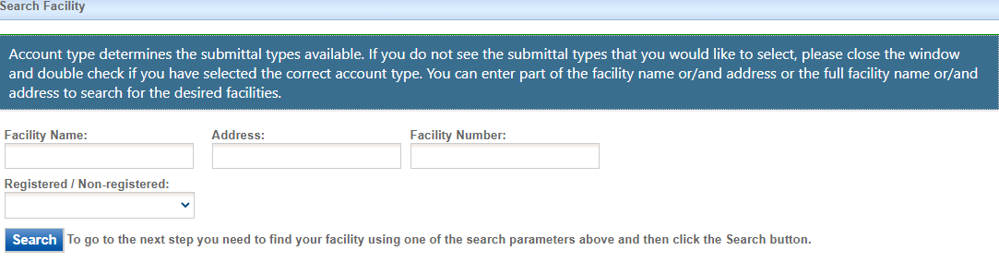

Figure 8 Associate Facility Search

The facility information will appear below the facility search as shown in Figure 9. Select the check box for the facility and the “Construction – Paint Booth Permit-by-Rule” check box under submission type.

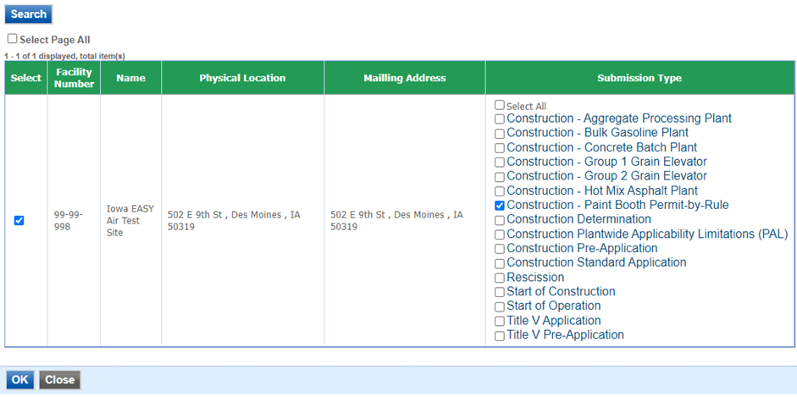

Figure 9 Facility Search Results and Adding Submission Type

Next, click “Ok” and then click “Close”. This will associate the Paint Booth Permit-by-Rule application to your account. If you went through the e-Verify subscriber agreement process when you set up your account, you will be able to use the Paint Booth Permit-by-Rule application after this step. However, if you sent in the paper subscriber agreement form, you will have to wait until the Iowa EASY Air Administrator completes the association of the Paint Booth Permit-by-Rule application to your account. You will receive an email from the Iowa EASY Air Administrator when the association of the Paint Booth Permit-by-Rule application has been made to your account.

# Finding the Paint Booth Permit-by-Rule Application

There are two ways to start an application within the Iowa EASY Air system. For one method, on your dashboard you can click on the “Apply for a New Submittal” button in the upper left-hand corner of the dashboard as shown in Figure 10.



Figure 10 Dashboard Buttons to Create a New Submittal

Alternatively, hover over the “Submittal” tab and select “Start a New Submittal” as shown in Figure 11.



Figure 11 Submittal Menu

Next, you will see the application icons for the different types of submittals available to you in the system. The Construction – Paint Booth Permit-by-Rule icon is shown below in Figure 12. Please select “Start” at the bottom right hand corner of the icon to start the Paint Booth Permit-by-Rule application.

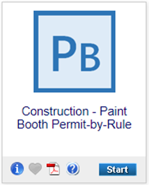

Figure 12 Construction – Paint Booth Permit-by-Rule Icon

# Filling Out and Submitting a Paint Booth Permit-by-Rule Application

In order to apply for a Paint Booth Permit-by-Rule, you must first verify that the proposed facility meets the limitations contained in the permit-by-rule. The Iowa EASY Air application has been designed to walk you through each part of the permit-by-rule to verify that the proposed facility will meet the limitations established in the permit-by-rule document. The permit-by-rule will not be valid until reviewed and issued by the Department.

No changes may be made to any of the conditions. If you cannot meet those conditions or want to operate differently, you should complete a Construction Standard Application for each emission unit at the facility.

## Facilities Eligible for Permit by Rule

Next, the Facilities Eligible for Permit by Rule screen will appear (see Figure 13). This section lists the reference to the eligibility requirements in the Iowa Administrative Code (IAC) at 22.8(1), and the facility must certify that the facility is currently or will be in compliance with or otherwise exempt from the requirements of the National Emissions Standards for Hazardous Air Pollutants (NESHAP) for Miscellaneous Surface Coating Operations at Area Sources (40 CFR Part 63, Subpart HHHHHH) and the NESHAP for Metal Fabrication and Finishing at Area Sources (40 CFR Part 63, Subpart XXXXXX) by the applicable NESHAP compliance dates. Once you have reviewed these references and have determined that the permit-by-rule is applicable to your facility, please check the box at the bottom that you have read the section, then click on “Save” and then “Next”.

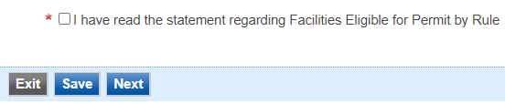

Figure 13 Facilities Eligible for Permit by Rule Statement

## Contact Information

Next, the Contact Information screen will appear (see Figure 14 and 15).

#### Facility Contact Information

Please provide the name and contact information for the person within the company who should be contacted regarding questions or other pertinent information related to the registration application. If this person is the responsible official, please check the box stating this. All fields with a red asterisk are required to be filled in.

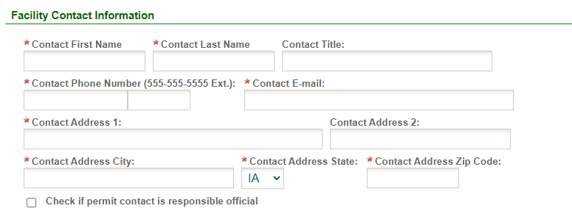

Figure 14 Facility Contact Information

#### Facility Information

Please click on the “Company/Facility Name:” dropdown box and select the Company/Facility Name that the permit should be associated to. The facility address will auto-fill. If the facility information is not correct, please contact [easyair@dnr.iowa.gov](mailto:easyair@dnr.iowa.gov) to change the facility information.

Next, enter the equipment location. If you select “Same as Facility Address”, the information will be copied from the facility address information.

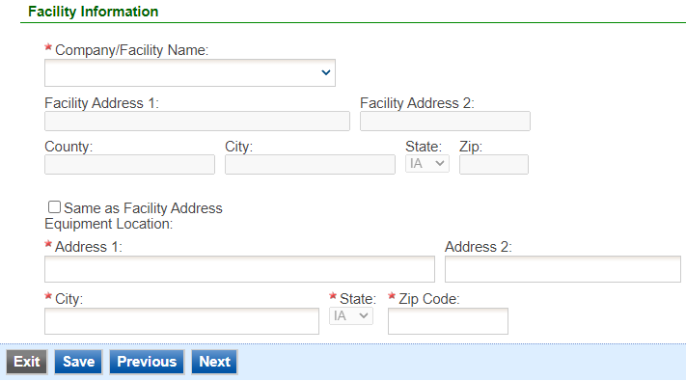

Figure 15 Facility Information

Once you have finished entering the information, click “Save” and then “Next”. If there is required information missing from the section, the Iowa EASY Air system will highlight the required fields in red. You may proceed with the application, but the system will not allow you to submit the application until all the required fields are completed during the Validation step.

## Applicability Question

Next, the Applicability Question screen will appear (see Figure 16). This section has been designed to assist with determining the applicable requirements for the facility based on the facility-wide usage of spray material per day, the type of materials being coated, and the primary activity of the facility. Please read the questions carefully and use the radio buttons and checkboxes to answer the questions based on the facility’s proposed operation. Depending on the selections made, there will be separate follow-up questions asked and the Iowa EASY Air system will show the facility’s applicability to the National Emission Standards for Hazardous Air Pollutants (NESHAP) program.

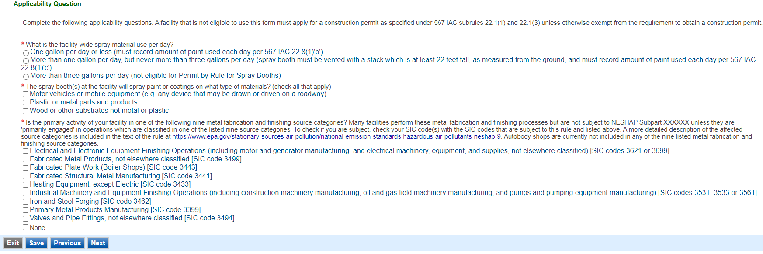

Figure 16 Applicability Question Summary

An explanation of each question is listed below:

1. What is the facility-wide spray material use **per day**?

Select one of the following radio buttons, based on the estimated (or actual, if data is available) paint usage per day. Depending on the choice, the facility is subject to the requirements shown in parentheses. If the facility-wide spray material usage is greater than three gallons per day, the facility is not eligible for a Permit by Rule for Spray Booths and must complete a Construction Standard Application to permit the source. Go to question 2 if the facility is eligible to use the permit-by-rule.

* One gallon per day or less (must record amount of paint used each day per 22.8(1)”b”)
* More than one gallon per day, but never more than three gallons per day (spray booth must be vented with a stack which is at least 22 feet tall, as measured from the ground, and must record amount of paint used each day per 22.8(1)”c”)
* More than three gallons per day (not eligible for Permit by Rule for Spray Booths)

1. The spray booth(s) at the facility will spray paint or coatings on what type of materials?

Check all the materials that the facility will spray paint or apply coatings to. Once you have entered the materials, go to Question 3.

* Motor vehicles or mobile equipment (e.g. any device that may be drawn or driven on a roadway)
* Plastic or metal parts and products
* Wood or other substrates not metal or plastic

1. Is the primary activity of your facility in one of the following nine metal fabrication and finishing source categories? Many facilities perform these metal fabrication and finishing processes but are not subject to NESHAP Subpart XXXXXX unless they are ‘primarily engaged’ in operations which are classified in one of the listed nine source categories. To check if you are subject, check your SIC code(s) with the SIC codes that are subject to this rule and listed above. A more detailed description of the affected source categories is included in the text of the rule at [Metal Fabrication and Finishing Source Categories: National Emission Standards for Hazardous Air Pollutants (NESHAP) Area Source Standards](https://www.epa.gov/stationary-sources-air-pollution/metal-fabrication-and-finishing-source-categories-national). Autobody shops are currently not included in any of the nine listed metal fabrication and finishing source categories.

Check all that apply below and proceed to Question 5. If none of the categories below apply to your facility, check “none” below and proceed to Question 4.

* Electrical and Electronic Equipment Finishing Operations (including motor and generator manufacturing, and electrical machinery, equipment, and supplies, not elsewhere classified) [SIC codes 3621 or 3699]
* Fabricated Metal Products, not elsewhere classified [SIC code 3499]
* Fabricated Plate Work (Boiler Shops) [SIC code 3443]
* Fabricated Structural Metal Manufacturing [SIC code 3441]
* Heating Equipment, except Electric [SIC code 3433]
* Industrial Machinery and Equipment Finishing Operations (including construction machinery manufacturing; oil and gas field machinery manufacturing; and pumps and pumping equipment manufacturing) [SIC codes 3531, 3533 or 3561]
* Iron and Steel Forging [SIC code 3462]
* Primary Metal Products Manufacturing [SIC code 3399]
* Valves and Pipe Fittings, not elsewhere classified [SIC code 3494]
* None

1. Are the operations at your facility specifically exempt from NESHAP Subpart HHHHHH - Miscellaneous Surface Coating Operations at Area Sources? A complete list of exemptions is included in 40 CFR §63.1169(d).

Check all the following that apply. If the exemptions apply, the spray booth(s) are not subject to the requirements of 40 CFR Part 63, Subpart HHHHHH or Subpart XXXXXX and you may proceed with the next part of the application by clicking on “Save” and then “Next”. If none of these exemptions apply, select “No” and proceed to question 6.

* Surface coating is performed only on wood, leather, rubber, ceramics, stone, masonry or substrates other than metal or plastic
* Coatings applied consist only of adhesives, sealants, maskants, caulking materials or decorative, protective or functional materials that consist only of protective oils for metal, acids or bases
* Surface coating performed on site at installations owned or operated by the US Armed Forces, NASA or the National Nuclear Security Administration
* Surface coating of military munitions, as defined in §63.11180, manufactured by or for the US Armed Forces or equipment directly and exclusively used for the purposes of transporting military munitions
* Coating performed by an individual on their possessions (not including motor vehicles or mobile equipment), either for hobby or maintenance
* Coating performed by an individual on others’ possessions (not including motor vehicles or mobile equipment), either for hobby or maintenance for which no compensation is received
* Coating performed by an individual on personal or others’ motor vehicles or mobile equipment as long as no compensation is received and no more than two vehicles or pieces of mobile equipment are coated per year
* Surface coating that meets the definition of ‘research and laboratory activities’ in §63.11180
* Surface coating that meets the definition of ‘quality control activities’ in §63.11180
* Surface coating activities that are covered under another area source NESHAP

1. Are all the operations at your facility specifically exempt from NESHAP Subpart XXXXXX Metal Fabrication and Finishing Operations? A complete list of exemptions is included in 40 CFR §63.11514.

Check all the following that apply. If the exemptions apply, the spray booth(s) are not subject to the requirements of 40 CFR Part 63, Subpart HHHHHH or Subpart XXXXXX and you may proceed with the next part of the application by clicking on “Save” and then “Next”. If none of these exemptions apply, select “No” and proceed to question 6.

* Surface coating performed at research or laboratory facilities as defined in section 112(c)(7) of the CAA
* Surface coating performed at tool or equipment repair operations, for facility maintenance or for quality control as defined in §63.11522
* Surface coating performed on site at installations owned or operated by the US Armed Forces, NASA or the National Nuclear Security Administration
* Surface coating of military munitions, as defined in §63.11522, manufactured by or for the US Armed Forces or equipment directly and exclusively used for the purposes of transporting military munitions

1. Do the paint or coatings spray applied in your booth(s) contain Cadmium, Chromium, Lead, Manganese or Nickel? In order for a coating or paint to contain these compounds as defined under the NESHAP, the compounds must be present in concentrations equal to or greater than 0.1 percent by mass for Cadmium, Chromium, Lead and Nickel or be present in concentrations equal to or greater than 1.0 percent by mass for Manganese. Refer to product MSDS, Manufacturer’s Product Specification Sheet, or contact the coating or paint manufacturer directly to determine if the coating or paint contain any of the compounds at the defined concentrations.

Select either “Yes” or “No”. If you selected “Yes”, the spray booth(s) are subject to the requirements of 40 CFR Part 63, Subpart HHHHHH if you selected “None” in question 3 and “No” in question 4. If you selected “Yes”, the spray booth(s) are subject to the requirements of 40 CFR Part 63, Subpart XXXXXX if you selected any category besides “None” in question 3 and “No” in question 5. If you selected “No”, the spray booth(s) are not subject to the requirements of 40 CFR Part 63, Subpart HHHHHH or Subpart XXXXXX and you may proceed with the next part of the application by clicking on “Save” and then “Next”.

For spray booth(s) subject to 40 CFR Part 63, Subpart XXXXXX, please refer to the full rule text of 40 CFR Part 63, Subpart XXXXXX available at [National Emission Standards for Hazardous Air Pollutants (NESHAP)](https://www.epa.gov/stationary-sources-air-pollution/national-emission-standards-hazardous-air-pollutants-neshap-9) to determine all applicable equipment requirements, management practices, monitoring requirements, recordkeeping requirements, and reporting requirements necessary to be in compliance with this rule. NESHAP Subpart XXXXXX applies not only to spray booths, but also to dry abrasive blasting, machining, dry grinding and polishing with machines and welding. If a facility that is primarily engaged in one of the nine metal fabrication and finishing operations listed in question 3 also performs any other of these industrial processes, it is possible that these other operations are subject to NESHAP Subpart XXXXXX. Each industrial process is regulated only if they use materials that contain or have the potential to emit the compounds listed in question 6. Any operations other than spray booths subject to the requirements of NESHAP Subpart XXXXXX may be required to obtain a construction permit unless otherwise exempt. The DNR has also developed a summary of requirements for this rule for each industrial process. These documents are available on our website at [Air Toxics - NESHAP](http://www.iowadnr.gov/InsideDNR/RegulatoryAir/AirToxics-NESHAP.aspx).

For spray booth(s) subject to 40 CFR Part 63, Subpart HHHHHH, please refer to the full rule text of 40 CFR Part 63, Subpart HHHHHH available at [National Emission Standards Hazardous Air Pollutants (NESHAP)](https://www.epa.gov/stationary-sources-air-pollution/national-emission-standards-hazardous-air-pollutants-neshap-9) to determine all applicable equipment requirements, management practices, monitoring requirements, recordkeeping requirements, and reporting requirements necessary to be in compliance with this rule. The DNR has also developed a guide to the NESHAP for Miscellaneous Surface Coating Operations at Area Sources. This guide is available on our website at [Air Toxics - NESHAP](http://www.iowadnr.gov/InsideDNR/RegulatoryAir/AirToxics-NESHAP.aspx).

Once you have reviewed the questions and have determined that the permit-by-rule is applicable to your facility, please click on “Save” and then “Next”.

## Lead Applicability

Next, the Lead Applicability screen will appear. This screen is to determine applicability to requirements if the spray booth(s) are installed, reconstructed, or altered after October 23, 2013 and use any sprayed material containing lead. Initiation of construction, installation, or alteration means the significant permanent modification of a site to install equipment, control equipment or permanent structures. Not included are activities incident to preliminary engineering, environmental studies, or acquisition of a site for a facility.

Please respond to the question by selecting either “yes” or “no”. If you answered yes, the lead content of any spray material shall not exceed 0.35 pounds per gallon. This lead content limit is in addition to any applicable requirements from NESHAP Subpart HHHHHH. You must keep safety data sheets (SDS) or equivalent records for at least two calendar years to demonstrate that the sprayed material meets the lead content limit. If you answered no, there are no further requirements.

Once you have answered the question, please click on “Save” and then “Next”.

## Spray Booth Description

Next, the Spray Booth Description screen will appear. This section is for entering the spray booth(s) information into the Permit-by-Rule, and is required for all applications. To add a spray booth, click on “Add New Record” on the bottom of the table shown in Figure 17. Text boxes for the “Spray Booth ID”, “Spray Booth Location”, and a drop-down menu for “Spray Gun Type” will appear as shown in Figure 18.

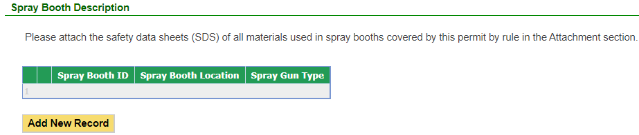

Figure 17 Spray Booth Description Screen

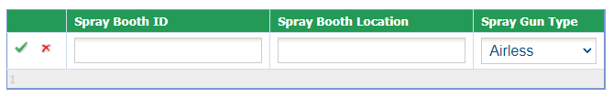

Figure 18 Spray Booth Description Detail Screen

Please enter the information in each text box for each spray booth for the proposed Spray Booth Permit-by-Rule. An example spray booth is shown below in Figure 19.

When you are finished with entering information for a piece of equipment, click the green “checkmark” to add the equipment to the list. If you need to remove equipment from the list, you may click the red “x” to delete the equipment from the list.

Below is an explanation for the corresponding field on the form:

**Spray Booth ID:** Provide the identifier that the facility will use for this spray booth. This may either be the serial number of the process equipment, a specific company ID that the facility uses for this equipment, or an Emission Unit (EU) ID.

**Spray Booth Location:** Provide a basic description of the location of the equipment (for example; N.E. Corner of building A).

**Spray Gun Type:** Select either “Airless”, “Conventional”, “Electrostatic”, or “HVLP” from the drop-down menu. Definitions for these terms are listed below for reference:

“Airless” - Airless spray application is the process of pushing a coating at high pressure (e.g., 3000 psi) through a small orifice (e.g., 0.023”), then releasing the pressure back to atmospheric pressure as the paint exits the spray tip. The pressure differential (high to low) causes the coating to atomize. The pressure is applied to the coating using a reciprocating pump that is operated using compressed air, electricity or fuel (gasoline). Airless spray is the most common method of spray application on industrial structures.

“Conventional” - Conventional or air-atomized spray uses clean, dry compressed air to both transfer the coating from a pressurized pot into the material hose (known as pot pressure) and to atomize the stream of paint as it exits the nozzle of the spray gun (known as atomization pressure).

“Electrostatic” - Electrostatic spray uses a specialized solution that is combined with air and atomized by an electrode inside the sprayer. Subsequently, the spray contains positively charged particles that are able to aggressively adhere to surfaces and objects. Because the particles in the spray are positively charged, they cling to and coat any surface they’re aimed at.

“HVLP” - HVLP is an acronym for High Volume Low Pressure which means a high volume of air (10-25 CFM) at a low air pressure (10 PSI/0.7 Bar or less). Atomization is achieved by the volume of air not by high air pressure which reduces the forward velocity, thus creating a softer spray.

Please click “save” at the bottom of the screen to save the equipment description(s) to the application.

If you do not click “save” before loading into another page, you will lose your current progress entering information.

Once you have entered equipment to the list and confirmed it with the green “checkmark”, you may edit the equipment using the “pencil and paper” icon, or delete the record using the “red x” icon shown below. If you choose to delete the record, the Iowa EASY Air system will confirm with you that you want to delete the record with a pop-up message. Select “Ok” on this message to confirm, or “Cancel” to stop the deletion request.

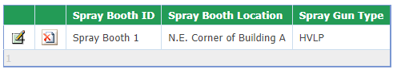

Figure 19 Spray Booth Description Example

When you are finished filling out this form, please click, “Save” and then “Next”. Please click “Save”, if you want to save your work and return to the form at any time.

## Spray Booth Certification

Next, the Spray Booth Certification screen will appear. This screen will have different information presented depending on the answers provided in the Applicability Question screen. All facilities must complete the following certification:

“I certify that all spray booths at the facility are in compliance with all applicable requirements of rule 567 IAC 22.8(1)(455B). I understand that this equipment shall be deemed permitted under the terms of 567 IAC 22.8(1)(455B) only if all applicable requirements of 567 IAC 22.8(1)(455B) are met. This certification is based on information and belief formed after reasonable inquiry, the statements and information in the document are true, accurate, and complete.”

There are four separate scenarios for this form, based on the answers completed in the Applicability Question screen.

* The following certification must be completed for facilities that spray paint or other coatings on “motor vehicles or mobile equipment”, and do not apply paint or coatings containing cadmium, chromium, lead, manganese, or nickel:

“I certify that none of the coatings used in my motor vehicle or mobile equipment spray booth contain Cadmium, Chromium, Lead, Manganese or Nickel. I understand that if circumstances change, such that I intend to spray apply coatings containing these materials, I shall comply with the requirements of the NESHAP for Miscellaneous Surface Coating (40 CFR Part 63, Subpart HHHHHH) and submit the initial notification required by §63.11175.”

These facilities must also complete the following question, in addition to this certification:

“I intend to use the following types of coatings in my motor vehicle or mobile equipment spray booth: (for example: polyurethane coatings):”

* The following certification must be completed for facilities that spray paint or other coatings on “plastic or metal parts and products”, and do not apply paint or coatings containing cadmium, chromium, lead, manganese, or nickel:

“I acknowledge that none of the coatings used in my spray booth contain Cadmium, Chromium, Lead, Manganese or Nickel. I understand that if circumstances change, such that I intend to spray apply coatings containing these materials, I shall comply with the requirements of 40 CFR Part 63, Subpart HHHHHH and submit the initial notification required.”

* The following certification must be completed for facilities that are subject to 40 CFR Part 63, Subpart XXXXXX, as stated on the Applicability Question screen:

“I certify that I am subject to 40 CFR Part 63, Subpart XXXXXX, as specified in this form. I understand that I must submit all subsequent notifications and reports as required by the applicable NESHAP. I further certify that in regards to Subpart XXXXXX the facility: (select one of the two options)

* currently is in compliance with 40 CFR Part 63, Subpart XXXXXX by the applicable NESHAP compliance dates (for facilities that are already operating at the time this form is submitted)
* will be in compliance with 40 CFR Part 63, Subpart XXXXXX upon startup (for facilities that have not yet begun operating at the time this form is submitted).
* The following certification must be completed for facilities that are subject to 40 CFR Part 63, Subpart HHHHHH, as stated on the Applicability Question screen:

I certify that I am subject to 40 CFR Part 63, Subpart HHHHHH, as specified in this form. I understand that I must submit all subsequent notifications and reports as required by the applicable NESHAP. I further certify that in regards to Subpart HHHHHH the facility: (select one of the two options)

* currently is in compliance with 40 CFR Part 63, Subpart HHHHHH by the applicable NESHAP compliance dates (for facilities that are already operating at the time this form is submitted)
* will be in compliance with 40 CFR Part 63, Subpart HHHHHH upon startup (for facilities that have not yet begun operating at the time this form is submitted).

When you are finished filling out this form, please click, “Save” and then “Next”.

## Attachments

Next, the Attachments screen will appear (see Figure 20). Please attach Safety Data Sheets (SDS) to this application for each coating used in the spray booth(s) listed in the Spray Booth Description screen.

Attachments may be uploaded to the application electronically, or mailed/faxed to the Department.

The Iowa DNR recommends that attachments be submitted electronically so as to not slow down the application process.

Please attach any documents required to assist the assigned engineer with completing the project on this screen.

To include your attachment(s) in the Iowa EASY Air system, select the “Online” radio button and then click on the “Upload” button. Only one file may be uploaded at a time, and the maximum file size allowed is 100 MB.

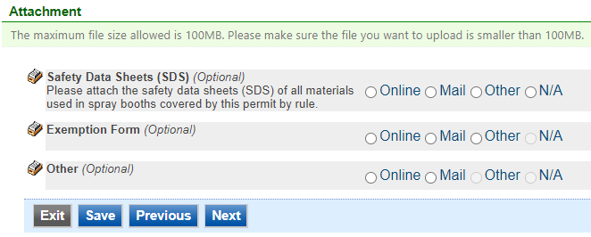

Figure 20 Attachment Screen

Select “Choose File” to select the document to be uploaded (see Figure 21). These file types are accepted by the system:

* pdf, doc, docx, txt, xls, xlsx, cvs
* jpeg, jpg, bmp, png, gif
* xml

You may include a comment for each attachment. When you have successfully selected the document, click on “Save” to upload the attachment.

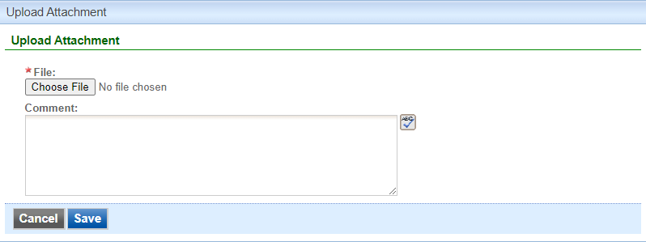

Figure 21 Attachment Screen

The uploaded attachment will display on the screen as shown in Figure 22. To remove an attachment, click the red “x” icon. The Iowa EASY Air system will confirm with you that you want to delete the record with a pop-up message. Select “Ok” on this message to confirm, or “Cancel” to stop the deletion request. To edit the attachment comment, click on the attachment comment, edit the comment, then select “Save” to update the comment or “Cancel” to cancel the change.

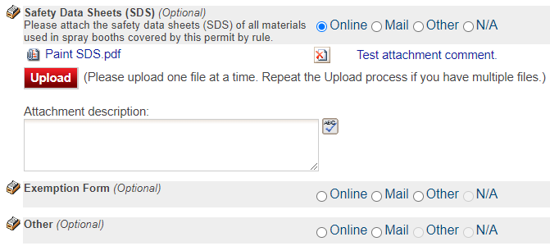

Figure 22 Example Attachment Screen

Please click “save” at the bottom of the screen to save the page.

If you do not click “save” before loading into another page, you will lose your current progress entering information.

If you plan to mail or fax the attachments, please select the “Mail” radio button on the attachment screen. If mailing attachments, include the attachment descriptions and submittal ID. Mail attachments to the following address:

Application Login Desk

Air Quality Bureau

502 E 9th Street

Des Moines, IA 50319

If faxing documents, include the attachment descriptions and submittal ID. The Air Quality Bureau fax number is (515) 725-9501.

## Validation

Next, the Validation screen will appear (see Figure 23). The system will check the application forms for required information that is missing, and will display a result similar to the figure below:

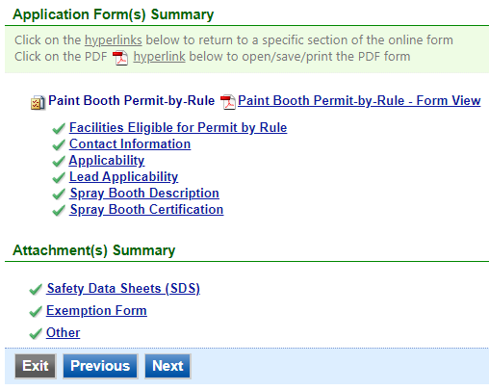

Figure 23 Example Validation Screen

If there are no noted issues, click the “Next” button. If there are issues, you may navigate to the section by selecting the section on this screen to complete the missing information.

Please note that the system will only check for missing information, and will not validate whether the information is complete or accurate.

## Payment

Next, the Payment screen will appear (see Figure 24). The application fee for a Paint Booth Permit-by-Rule is $100.00 per application for each plant. You may pay for the application fee by Credit Card, Check, Money Order, or eCheck (ACH – NACHA).

The Iowa DNR recommends that payment be submitted electronically (Credit Card or eCheck) so as to not slow down the application process.

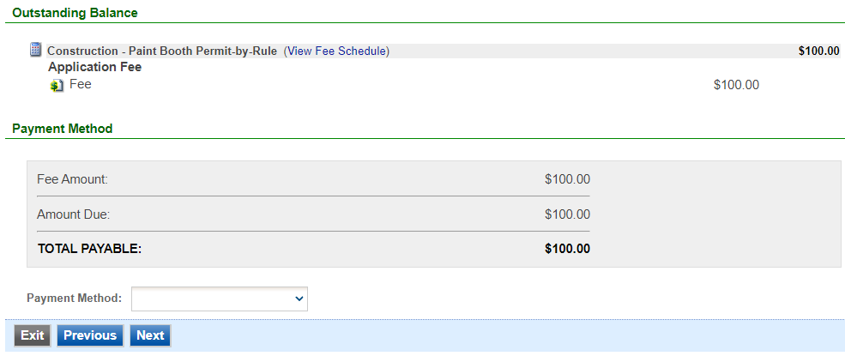

Figure 24 Example Payment Screen

If paying by Credit Card or eCheck, please use the “Online Checkout” option in the dropdown menu. The system will request the applicable information for each type of payment. If paying by Check or Money Order, select the appropriate method in the dropdown menu. When sending the payment via mail, please use the following information for payment:

* Pay To: Iowa Department of Natural Resources
* Address: Wallace State Office Building 502 E 9th St, 4th Floor, Des Moines IA 50319
* Please print a copy of the submittal receipt and mail it in with the payment or write the submittal ID number on the check or money order.

When you have finished, click the “Next” button.

## Submission

Next, the Certification of Submission screen will appear (see Figure 25). Please review the statement at the top of the screen, then check the box at the top of the screen, answer the security question, enter your pin, and click “Submit”.

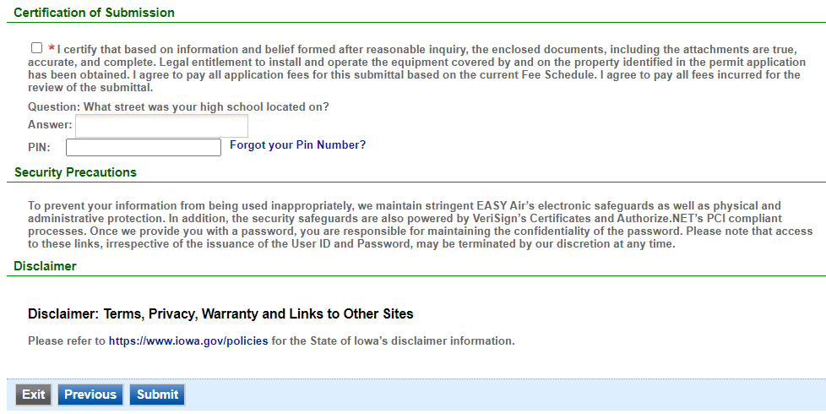

Figure 25 Example Certificate of Submission Screen

You will get a confirmation screen similar to the one shown below in figure 26 and a confirmation email will be sent to you.

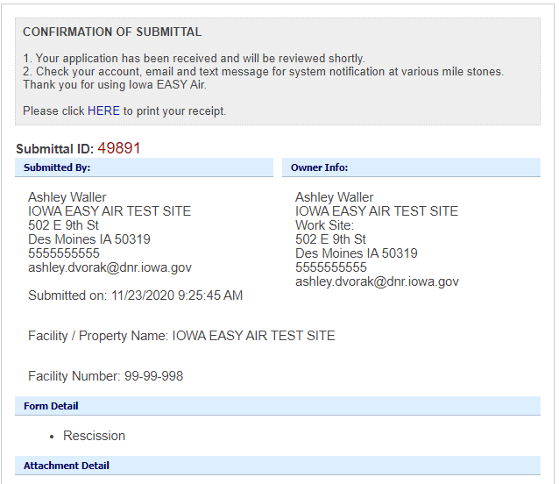

Figure 26 Confirmation of Submittal

**If you have questions, please call the Iowa EASY Air Helpdesk  
at (515) 725-9569 or (515) 204-3749.**

**Or, send an email to** [**easyair@dnr.iowa.gov**](mailto:easyair@dnr.iowa.gov)